EXPERIMENT NO : 06
Aim

1. HTML File — index.html
<!DOCTYPE html>
<html lang="en">
<head>
<meta charset="UTF-8">
<meta name="viewport"
content="width=device-width, initial-scale=1.0">
<title>Interactive Student Profile</title>
<link rel="stylesheet" href="style.css">
</head>
<body>
<div class="profile-container">
<h1>Student Profile</h1>
<!-- Profile Image -->
<img src="student.jpg"
alt="Student Profile"
id="profileImage"
class="profile-image">
<!-- Student Information -->
<h2 id="studentName">
Niharika Pradhan
</h2>
<p>
<strong>Department:</strong>
Computer Engineering
</p>
<p>
<strong>Semester:</strong>
7th Semester
</p>
<!-- About Section -->
<div id="aboutSection">
<h3>About Me</h3>
<p id="aboutText">
I am a Computer Engineering student interested
in web technologies, programming and learning
new technologies.
</p>
</div>
<!-- Skills Section -->
<div class="skills">
<h3>Skills</h3>
<ul>
<li>HTML</li>
<li>CSS</li>
<li>JavaScript</li>
<li>Python</li>
</ul>
</div>
<!-- Change Name -->
<div class="control">

<input type="text"
id="nameInput"
placeholder="Enter new name">
<button id="nameButton">
Change Name
</button>
</div>
<!-- Change About -->
<div class="control">
<input type="text"
id="aboutInput"
placeholder="Enter new About text">
<button id="aboutButton">
Change About
</button>
</div>
<!-- Buttons -->
<div class="buttons">
<button id="colorButton">
Change Text Color
</button>
<button id="hideButton">
Hide About
</button>
<button id="darkButton">
Toggle Dark Mode
</button>
</div>
</div>
<!-- External JavaScript -->
<script src="script.js"></script>
</body>
</html>

2. External CSS File — style.css

body {
margin: 0;
padding: 30px;
font-family: Arial, sans-serif;
background-color: #eef4f8;
color: #333;
transition: 0.3s;
}

.profile-container {
width: 500px;
max-width: 90%;
margin: auto;
padding: 30px;
background-color: white;
border-radius: 15px;
text-align: center;
box-shadow: 0 0 12px gray;
}

h1 {
color: #0066cc;
margin-bottom: 25px;
}

.profile-image {
width: 140px;
height: 140px;
border-radius: 50%;
object-fit: cover;
border: 4px solid #0066cc;
}

h2 {
color: #0066cc;
margin-bottom: 10px;
}

h3 {
color: #444;
margin-top: 25px;
}

#aboutSection {
padding: 15px;
margin-top: 15px;
background-color: #eef7ff;
border-radius: 10px;
}

.skills {
text-align: left;
margin-top: 20px;
padding: 15px;

background-color: #f5f5f5;
border-radius: 10px;
}

.skills li {
margin: 8px;
}

.control {
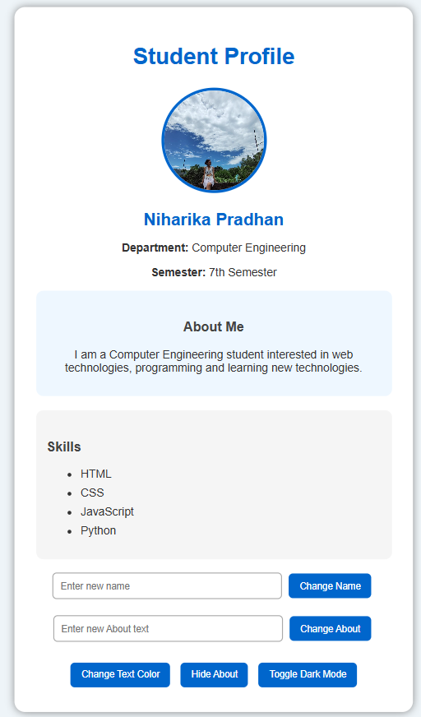
margin-top: 15px;
}

input {
width: 60%;
padding: 10px;
border: 1px solid #aaa;
border-radius: 6px;
}

button {
padding: 10px 15px;
margin: 5px;
border: none;
border-radius: 6px;
background-color: #0066cc;
color: white;
cursor: pointer;
}

button:hover {
background-color: #004c99;
}

.buttons {
margin-top: 20px;
}

/* Dark Mode */

.dark-mode {
background-color: #222;
color: white;
}

.dark-mode .profile-container {
background-color: #333;
}

.dark-mode #aboutSection {
background-color: #444;
}

.dark-mode .skills {
background-color: #444;
}

.dark-mode h3 {
color: #ddd;
}

3. JavaScript File — script.js

let aboutInput = document.getElementById("aboutInput");
let nameButton = document.getElementById("nameButton");
let aboutButton = document.getElementById("aboutButton");
let colorButton = document.getElementById("colorButton");
let hideButton = document.getElementById("hideButton");
let darkButton = document.getElementById("darkButton");
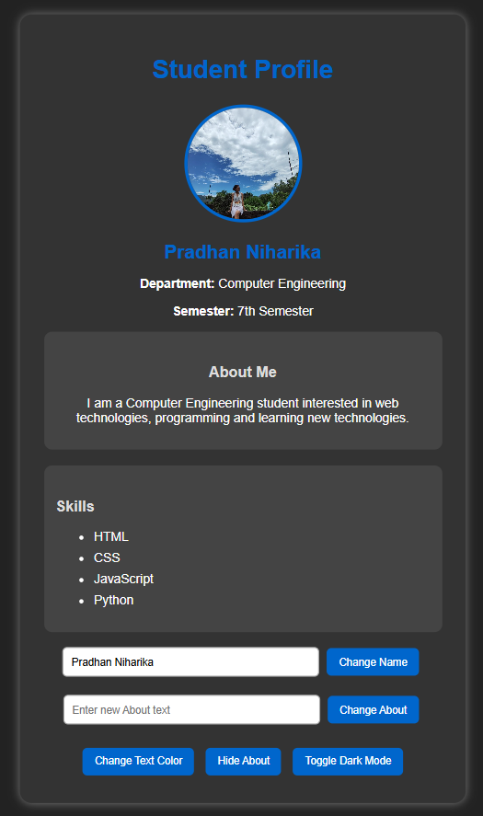
// Change Student Name
nameButton.addEventListener("click", function () {
studentName.textContent = nameInput.value;
});

// Change About Text
aboutButton.addEventListener("click", function () {
aboutText.textContent = aboutInput.value;
});

// Change Text Color
colorButton.addEventListener("click", function () {
studentName.style.color = "red";
});

// Hide / Show About Section
hideButton.addEventListener("click", function () {
if (aboutSection.style.display === "none") {
aboutSection.style.display = "block";
hideButton.textContent = "Hide About";
} else {
aboutSection.style.display = "none";
hideButton.textContent = "Show About";
}
});

// Toggle Dark Mode
darkButton.addEventListener("click", function () {
document.body.classList.toggle("dark-mode");
});

